Name_________________________________________

Place a X in the box below to indicate your Science Class

|  |  |  |  |  |  |
| --- | --- | --- | --- | --- | --- |
| 9B1  PCU | 9B2  LIF | 9B3  RWI | 9G1  NSH | 9G2  LIF | 9G3  TGA |

# College Crest - Black 2006

# ST ALOYSIUS’ COLLEGE

**2018**

### Year 9 Science

## Semester 2 Examination - Practise

|  |  |
| --- | --- |
| General Instructions  * Reading time: 5 minutes * Working time: 1 ½ hours * Write using black or blue pen * Write your name and Science class at the top of each **section**  1. Do not detach any pages 2. Hand in each part separately 3. You are advised to show all working, as marks may be awarded for relevant working 4. A periodic table and a table of polyatomic ion have been provided. | Total marks –- CHEMISTRY AND ACIDS |

## Part 1 Section 1: Chemistry and Acids- Multiple Choice Section *(8 marks)*

### Use the Multiple Choice answer sheet to answer these questions

Q1. What is an ion?

1. The part of an atom that contains electrons
2. A particle that can bind on to a neutral atom
3. An atom that has produced alpha particles
4. An atom that has lost or gained electrons

Q2. An ionic compound forms between:

1. Two non-metals
2. A metal and a non-metal
3. Two metals
4. An atom and an ion

Q3. The periodic table is organised into groups (the vertical columns) and periods (the horizontal rows). By looking at which GROUP an atom is in, you can determine:

1. The number of electrons in its outer shell
2. The number of electron shells it has
3. The total number of protons it has
4. Whether it is an anion or a cation

Q4. The information below is about 3 different unknown solutions. Select the answer that correctly identifies each solution as an acid or a base

Solution 1 has a pH of 3

Solution 2 feels slippery to touch

Solution 3 turns red litmus blue

|  |  |  |  |
| --- | --- | --- | --- |
| Your Answer | Solution Number | | |
| 1 | 2 | 3 |
| A. | Acid | Acid | Base |
| B. | Base | Acid | Base |
| C. | Acid | Base | Base |
| D. | Base | Base | Acid |

Q5. Recall what the products of all neutralisation reactions are

1. An acid and a base
2. An acid and an alkali
3. A salt and water
4. Water and hydrogen gas

Q6. A year 9 student conducted an experiment which involved mixing two chemicals. A chemical reaction occurred, which resulted in two products forming, one of which was a gas. They collected the gas in a test tube, and when they put a lit splint inside, the gas ignited with a squeaky “pop” sound.

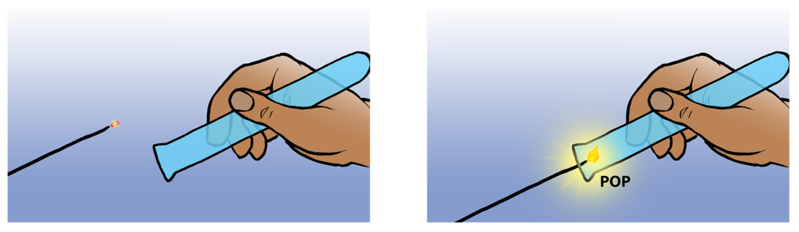

Select below the two chemicals that the student is likely to have mixed at the **start** of the experiment.

1. Sulfuric Acid and Sodium Hydroxide
2. Nitric Acid and Magnesium
3. Sodium Chloride and Water
4. Magnesium Nitrate and Hydrogen gas

Q7. Select the correct equation that summarises the events occurring in the following sentence:

If laboratory conditions are manipulated in the correct ways, water is able to be produced from a chemical reaction that involves breaking bonds within hydrogen molecules and oxygen molecules. New bonds are then formed between the hydrogen and oxygen atoms.

1. Water 🡪 Hydrogen + Oxygen
2. Water 🡪 Hydrogen + Oxygen 🡪 Hydrogen Oxide
3. Hydrogen + Oxygen 🡪 Carbon Dioxide
4. Hydrogen + Oxygen 🡪 Water

Q8. Which of the equations below correctly demonstrates the law of Conservation of Mass?

1. 3CO2 + 3H2O 🡪 C6H12O6 + 3O2
2. C6H12O6 + 6O2 🡪 6CO2 + 6H2O
3. CH4 + O2 🡪 CO2 + C
4. CH4 + O2 🡪 CO2 + 2H2O

Name_________________________________________

Place a X in the box below to indicate your Science Class

|  |  |  |  |  |  |
| --- | --- | --- | --- | --- | --- |
| 9B1  PCU | 9B2  LIF | 9B3  RWI | 9G1  NSH | 9G2  LIF | 9G3  TGA |

## Chemistry and Acids- Short Answer Section *(50 marks)*

### Question 9 (6 marks)

a) Identify two features of a solution that would classify it as a base. (2)

Feature 1- ____________________________________________________

Feature 2- ____________________________________________________

b) Complete the table to identify the name, chemical formula, classification and strength of the following acids and bases (3)

|  |  |  |  |
| --- | --- | --- | --- |
| Name of Chemical | Chemical Formula | Classification  (Acid or Base?) | Strong or Weak? |
| Acetic Acid | CH3COOH |  |  |
|  | NaOH |  |  |
|  | H2SO4 |  |  |
| Calcium Hydroxide |  |  | Strong |

c) Identify the difference between a weak acid and a strong acid in terms of what happens to them when they are dissolved in water (1)

________________________________________________________________

________________________________________________________________

________________________________________________________________

### Question 10 (5 marks)

1. Explain the difference between an ATOM of potassium and an ION of potassium. In your answer, you should make reference to:

protons, electrons, overall charge (4)

________________________________________________________________

________________________________________________________________

________________________________________________________________

________________________________________________________________

________________________________________________________________

________________________________________________________________

1. A potassium ion can react with any anion to form an ionic compound. Recall what is meant by the term “anion”? (1)

________________________________________________________________

________________________________________________________________

### Question 11 (15 marks)

1. An acid will react with most metals to produce a salt and one other product. Write the complete general word equation for this type of reaction below (2)

______________ + ______________ 🡪 ______________ + _____________

1. The salt that is produced in the type of reaction above will be made from elements contained in both the acid AND the metal it is reacting with. With this in mind, name the salts produced from the reactions between the following metals and acids (3)

Hydrochloric acid and aluminium ___________________________

Sulfuric acid and potassium ___________________________

Nitric acid and calcium ___________________________

1. A salt is one product of the reaction between potassium and sulfuric acid, but there is also another product formed.
2. Identify where the atoms in the other product come from (2)

________________________________________________________________

1. Write the word equation for the reaction between potassium and sulfuric acid (2)

________________________________________________________________

1. Write a balanced chemical equation for the reaction between potassium and sulfuric acid (3)

________________________________________________________________

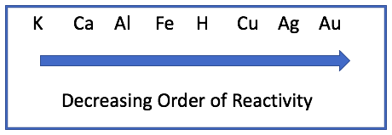**YOU WILL NEED TO USE INFORMATION IN THE REACTIVITY SERIES DIAGRAM BELOW TO HELP YOU ANSWER PART (d)**

1. A student conducted two experiments to investigate chemical reactions:

Experiment 1: Placing solid calcium into a test tube of sulfuric acid

Experiment 2: Placing solid aluminium into a test tube of sulfuric acid

1. Describe a similar observation that would likely be made in both experiments (1)

_________________________________________________________________  
_________________________________________________________________

1. Explain a difference that the student would expect in the two experiments (2)

________________________________________________________________

________________________________________________________________

________________________________________________________________

Name_________________________________________

Place a X in the box below to indicate your Science Class

|  |  |  |  |  |  |
| --- | --- | --- | --- | --- | --- |
| 9B1  PCU | 9B2  LIF | 9B3  RWI | 9G1  NSH | 9G2  LIF | 9G3  TGA |

### Question 12 (10 marks)

You will need to refer to the polyatomic ion data sheet (on periodic table sheet) to help you answer this question.

1. Nitrate (NO32-) and phosphate (PO43-) are two examples of polyatomic ions.

Describe what is meant by the term “polyatomic ion” (2)

________________________________________________________________

________________________________________________________________

________________________________________________________________

1. Ionic compounds will be formed when there is a reaction between a positively charged ion and a negatively charged ion.   
     
   Complete the equations below to show the correct reactants and products. Ensure you show the correct subscripts to represent the number of atoms of that element (NB: no subscript is needed to represent 1 atom) and superscripts to show the charge.

(You will need to use the periodic table to determine the charge/ valency for each ion) (4)

Eg.1 Cu2+  Eg.2 CuCl2

Superscript (charge) Subscript (number of atoms of Cl)

1. H+ + Cl- 🡪 _________________
2. _______ + F- 🡪 MgF2
3. _______ + _______ 🡪 Al2(CO3)3
4. Write the chemical equations (including relevant subscripts and superscripts) for the following reactions between the ions to show what ionic compound will form in each example.

### YOU ARE NOT REQUIRED TO BALANCE THESE EQUATIONS

1. Beryllium ion and hydroxide ion (2)

________ + ________ 🡪 ________

1. Calcium ion and phosphate ion (2)

________ + ________ 🡪 ________

### Question 13 (8 marks)

Write the word equations and balanced chemical equations for the reactions between the following reactants (all answers below should include both reactants AND products)

1. Hydrochloric acid plus sodium carbonate will form sodium chloride as well as water and carbon dioxide
2. Word Equation (2)

_________________________________________________________________

1. Chemical Equation (2)

_________________________________________________________________

1. Potassium hydroxide and Nitric acid
2. Word Equation (2)

_________________________________________________________________

1. Chemical Equation (2)

_________________________________________________________________

### Question 14 (6 marks)

The tables give information about two indicators, Bromothymol blue and Methyl orange.



The pH of three solutions was investigated using both indicators. The results are shown below.



1. Use a pencil to shade the bars below to represent the pH ranges that are indicated for each of the 3 substances (3)

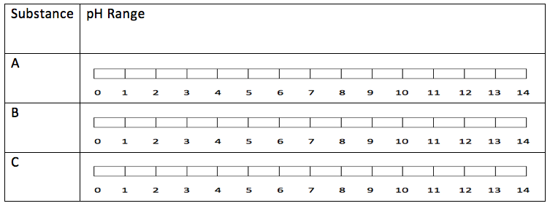

1. Based on the range you have identified for each substance, circle the correct description of each substance in the table below (3)

|  |  |  |  |  |  |  |
| --- | --- | --- | --- | --- | --- | --- |
| **Substance** | **Description of Substance** | | | | | |
| A | Strong Base | Weak Base | Neutral | Weak Acid | Strong Acid | Not enough information |
| B | Strong Base | Weak Base | Neutral | Weak Acid | Strong Acid | Not enough information |
| C | Strong Base | Weak Base | Neutral | Weak Acid | Strong Acid | Not enough information |

Name_________________________________________

Place a X in the box below to indicate your Science Class

|  |  |  |  |  |  |
| --- | --- | --- | --- | --- | --- |
| 9B1  PCU | 9B2  LIF | 9B3  RWI | 9G1  NSH | 9G2  LIF | 9G3  TGA |

## Part 1 Section 1 Multiple Choice Answer Sheet

Multiple Choice Questions (1 mark each)

Choose the best answer and mark the appropriate box with an ‘X

|  |  |  |  |  |
| --- | --- | --- | --- | --- |
|  | A | B | C | D |
| 1 |  |  |  |  |
| 2 |  |  |  |  |
| 3 |  |  |  |  |
| 4 |  |  |  |  |
| 5 |  |  |  |  |
| 6 |  |  |  |  |
| 7 |  |  |  |  |
| 8 |  |  |  |  |

|  |  |  |  |  |
| --- | --- | --- | --- | --- |

